Kalman Filter Drone Exercise
Full Report
Altitude estimation from real ArduPilot drone flight data
Scope. This report brings together the required work for the drone altitude Kalman filter exercise. It includes the barometer-only filter, the barometer + GPS altitude filter, the GPS vertical velocity extension, and the reflection questions. The flight log used is solar.mat. The state vector used throughout is x = [altitude; vertical_velocity]. The ArduPilot EKF altitude signal POS.RelHomeAlt is used as the comparison reference after shifting it to the same initial barometer altitude reference.

1. Exact files to submit
Submit the following files. The report is the main written document. The MATLAB scripts and PNG figures are the supporting evidence required by the exercise checklist.
Item | Submit this file | Why it is needed
Written report | kalman_filter_full_report.docx | Contains the explanations for Parts 1 to 4.
Part 1 code | kalmanFilter_part1.m | Barometer-only Kalman filter code.
Part 1 plot | part1_baro_only_altitude.png | Kalman estimate vs raw barometer vs ArduPilot EKF.
Part 2 code | kalmanFilter_part2.m | Barometer + GPS altitude fusion code.
Part 2 plot | part2_baro_gps_altitude.png | Barometer-only vs GPS-aided estimate vs EKF.
Part 3 code | kalmanFilter_part3.m | Barometer + GPS altitude + GPS vertical velocity fusion code.
Part 3 plot | part3_gps_altitude_velocity.png | Comparison of all three filters and velocity estimates.
Part 4 code | kalmanFilter_part4_outage.m | GPS outage and covariance evolution code.
Part 4 plot | part4_P_evolution_gps_outage.png | P diagonal entries with the 20 s GPS outage marked.
Do not submit solar.mat unless the lecturer specifically asks for the data file. The data file is large and is normally treated as the provided input, not as a result. Also keep the scripts and figures in the same folder when checking your work locally.

2. Data and filter setup
The main logged signals used in this report are the IMU acceleration, attitude, barometer altitude, GPS altitude, GPS vertical velocity, and ArduPilot POS.RelHomeAlt reference. The IMU timestamps are used as the prediction timeline because the IMU has the highest sampling rate. Barometer and GPS updates are applied only when their measurements actually arrive.
Quantity | Value
Common flight interval used | 312.48 s
IMU prediction samples | 56,855
Barometer samples in log | 1,953
GPS samples in log | 1,010
POS/EKF samples in log | 2,033
Initial barometer altitude reference | -0.361 m
Initial P matrix | diag([0.5, 0.1])
Acceleration process noise sigma_a | 0.30 m/s^2
R_baro from first 10 s stationary window | 0.160278 m^2
R_gps_alt from first 10 s stationary window | 0.007347 m^2
R_gps_vz from first 10 s stationary window | 0.033680 (m/s)^2
The discrete-time prediction model is based on constant acceleration over each small IMU time step:
x_k = F*x_(k-1) + B*a_z
F = [1 dt; 0 1], B = [0.5*dt^2; dt]
The process noise covariance was calculated from the acceleration noise standard deviation:
Q = sigma_a^2 * [dt^4/4 dt^3/2; dt^3/2 dt^2]

3. Part 1: Barometer-only Kalman filter

3.1 Task A: Running and tuning the existing script
Part 1 uses IMU vertical acceleration in the prediction step and BARO.Alt as the only measurement. The state is altitude and vertical velocity, but the barometer directly measures only altitude. The measurement matrix is therefore:
H = [1 0]
The initial uncertainty matrix was set to P0 = diag([0.5, 0.1]). This means that the initial altitude is assumed to be uncertain by a moderate amount, while the initial vertical velocity is also uncertain because the drone is not assumed to be perfectly still for the entire log. The acceleration process noise was set to sigma_a = 0.30 m/s^2. This value allows the filter to respond to real vertical motion while still smoothing high-frequency acceleration noise.
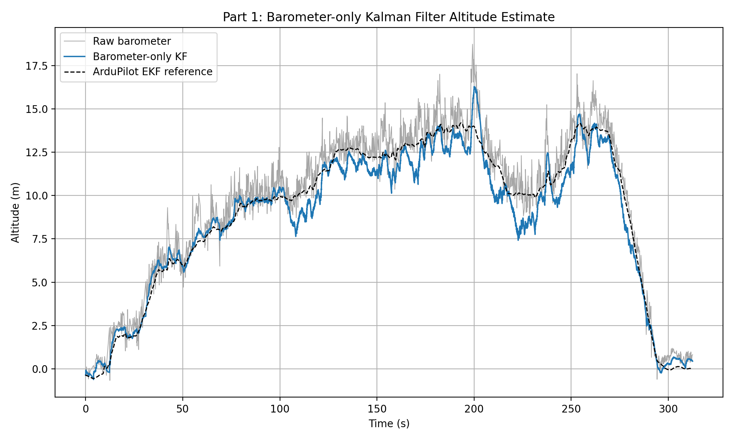
Figure 1: Part 1 barometer-only Kalman filter compared with raw barometer and ArduPilot EKF reference.
The raw barometer signal follows the general shape of the flight but is noisy. The barometer-only Kalman filter smooths the altitude trace and removes much of the measurement noise. It follows the ArduPilot EKF reference reasonably well during most of the flight, but some differences remain because the filter is much simpler than the ArduPilot EKF. The ArduPilot EKF uses a more complete sensor fusion system and vehicle model, while this exercise filter only uses a two-state vertical model with barometer updates and IMU acceleration input.
Using the ArduPilot EKF as the comparison reference, the barometer-only filter produced an altitude RMSE of about 0.820 m. This was the best RMSE in this run, mainly because the GPS altitude alignment and tuning in the later parts caused the GPS-aided filters to follow the GPS altitude more strongly than the EKF reference.

3.2 Task B: Estimating barometer noise R
The original starter code contained a manually selected barometer measurement noise value of R_baro = 0.0234 m^2. A sensor datasheet value was not available in the files used for this report, so this original value is treated only as the initial hand-selected comparison value.
A more data-based choice was calculated by taking the sample variance of BARO.Alt during the first 10 seconds of the common flight interval. This gave R_baro = 0.160278 m^2. This value is larger than the original hand-selected value, meaning the filter trusts the barometer less strongly and gives more weight to the prediction model between measurements.
R value | Value | Comment
Original hand-selected value in starter script | 0.0234 m^2 | Smaller value; filter trusts barometer more strongly.
Empirical stationary-window variance | 0.160278 m^2 | Calculated from the actual log; preferred for this submission.
For this exercise, the empirical value is better because it comes from the same flight log, the same sensor, and the same operating conditions. A true datasheet value would still be useful as a starting point, but it may not include installation effects, vibration, airflow, temperature changes, or log-specific bias. The stationary-window estimate is therefore more representative of the data being filtered.

4. Part 2: Adding GPS altitude

4.1 Method
Part 2 extends the barometer-only filter by adding GPS altitude as a second altitude measurement. The state vector remains the same, and the IMU prediction step is unchanged. The only difference is that the update step can now use either a barometer altitude sample or a GPS altitude sample whenever one arrives.
Both barometer altitude and GPS altitude measure the altitude state directly, so each scalar altitude update uses the same measurement matrix:
H = [1 0]
The barometer and GPS measurements are not forced onto a common sampling rate. Instead, the filter uses an event-based strategy. At each IMU prediction step, the code checks whether a barometer or GPS measurement occurred between the previous IMU timestamp and the current IMU timestamp. If a measurement occurred, the appropriate Kalman update is applied once.
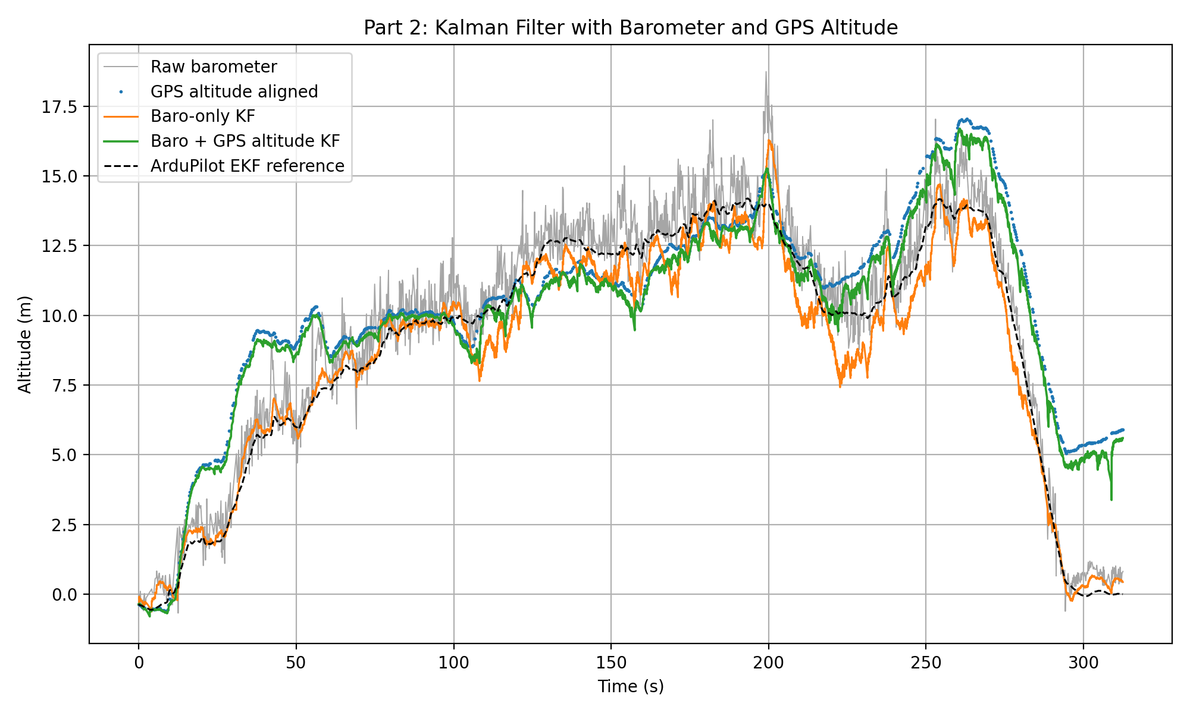
Figure 2: Part 2 comparison between barometer-only and barometer + GPS altitude Kalman filters.

4.2 Results and discussion
The GPS-aided filter follows the aligned GPS altitude more strongly than the barometer-only filter. In theory, adding GPS altitude can help reduce long-term barometer drift, because GPS provides an independent altitude measurement. In this specific log, however, the GPS-aided estimate does not improve the RMSE against the ArduPilot EKF reference. The likely reason is that the GPS altitude variance estimated from the first stationary window is small, so the filter trusts GPS strongly. If the GPS altitude contains bias, delay, multipath error or a datum mismatch, the filter can be pulled away from the EKF reference.
Estimate | RMSE vs EKF reference | Comment
Part 1: Barometer-only KF | 0.820 m | Lowest RMSE in this run.
Part 2: Barometer + GPS altitude KF | 2.117 m | Tracks GPS altitude strongly; higher RMSE here.
Part 3: Barometer + GPS altitude + VZ KF | 2.116 m | Similar altitude RMSE to Part 2, but velocity is corrected directly.
This result does not mean that GPS fusion is wrong. It shows that sensor fusion depends strongly on correct noise tuning, timestamp handling, and altitude reference alignment. A more advanced version could include a bias state for GPS/barometer offset or use a larger GPS altitude noise variance if the GPS signal is known to be unreliable.

5. Part 3: Adding GPS vertical velocity

5.1 Method
Part 3 adds GPS.VZ as a direct vertical velocity measurement. GPS altitude and GPS vertical velocity come from the same GPS message, so they are fused together in a single vector update. The GPS measurement vector is:
z_gps = [GPS altitude; GPS vertical velocity]
The GPS measurement matrix becomes:
H_gps = [1 0;
0 1]
The first row selects altitude and the second row selects vertical velocity. The GPS measurement noise matrix is diagonal:
R_gps = diag([R_gps_alt, R_gps_vz])
This assumes GPS altitude noise and GPS vertical velocity noise are independent. GPS.VZ is converted to the same sign convention as the filter state, where positive vertical velocity is upward.
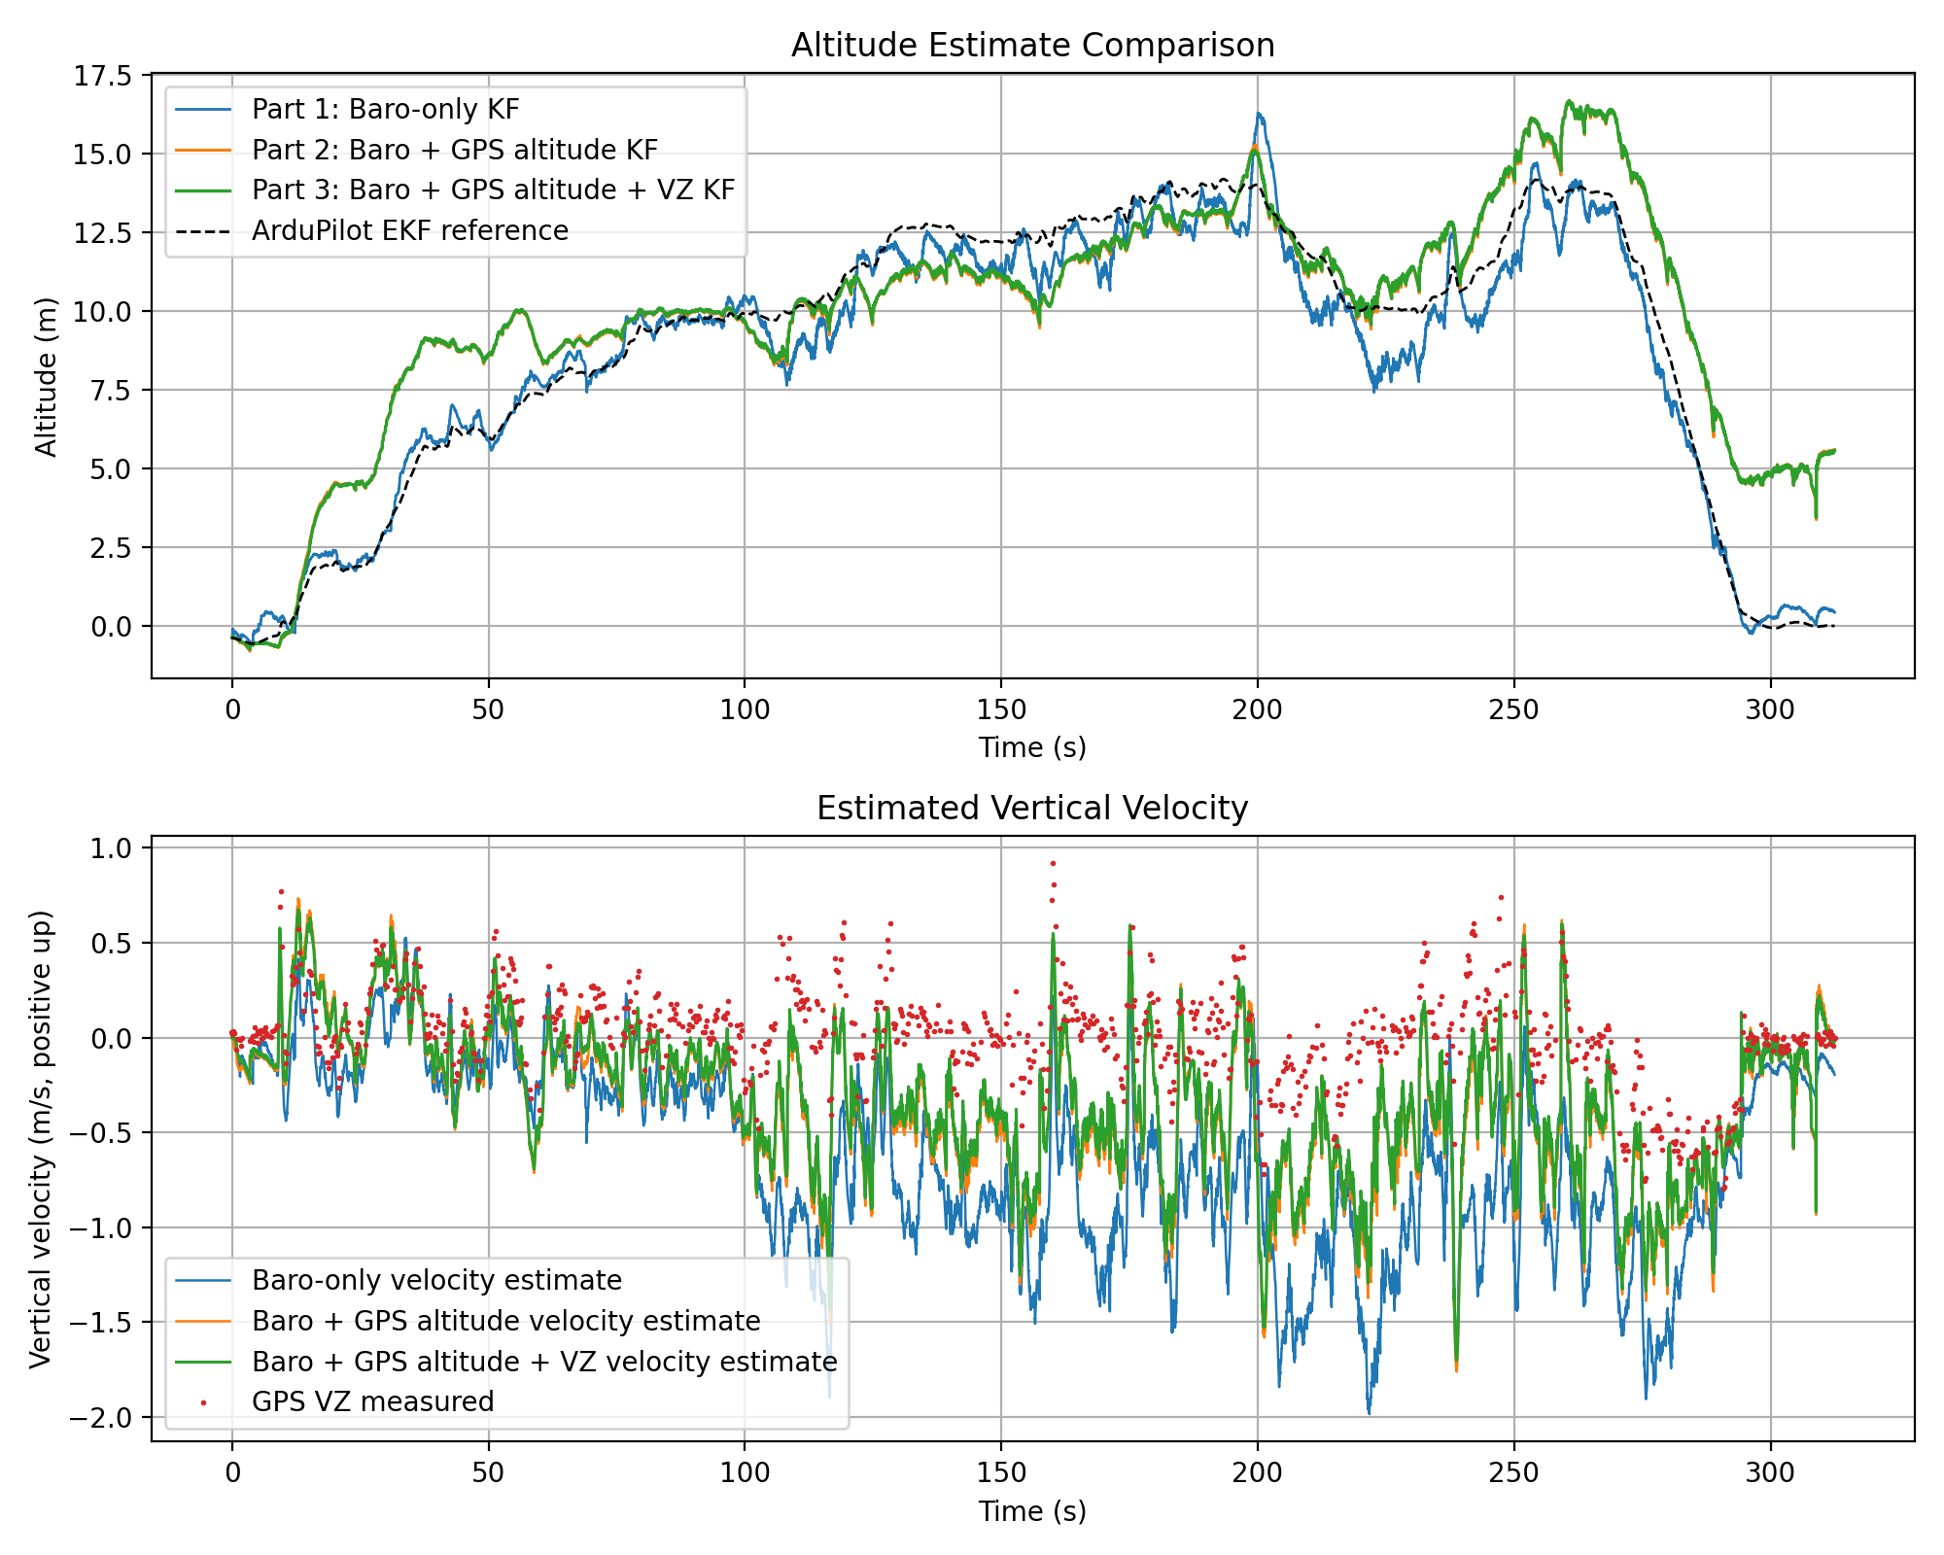
Figure 3: Part 3 comparison of all altitude estimates and vertical velocity estimates.
The altitude trace from Part 3 is very similar to Part 2 because GPS altitude still dominates the altitude correction. The main difference is in the velocity estimate. In Parts 1 and 2, velocity is only inferred indirectly through altitude updates and acceleration prediction. In Part 3, GPS.VZ directly corrects the velocity state. This makes the velocity state more sensor-informed, even though the altitude RMSE only changes slightly in this run.

6. Part 4 reflection

6.1 Task E: Measurement matrix H
The measurement matrix H maps the state vector into the measurement space. The state vector is always:
x = [altitude; vertical_velocity]
Task | Sensors used | H matrix | Dimensions | Physical meaning
Part 1 | Barometer altitude only | [1 0] | 1 x 2 | The barometer measures altitude only. It does not directly measure vertical velocity.
Part 2 | Barometer altitude and GPS altitude | Each scalar update uses [1 0] | 1 x 2 for each update | Both sensors measure altitude. They are processed as separate scalar updates because their timestamps and R values differ.
Part 3 | Barometer altitude plus GPS altitude and GPS vertical velocity | Baro: [1 0]  GPS: [1 0; 0 1] | Baro: 1 x 2  GPS: 2 x 2 | The GPS vector update measures altitude and vertical velocity. Row 1 selects altitude; row 2 selects velocity.
As more sensors are added, H gains extra rows when the measurement vector contains more measured quantities. H does not change the state itself. It only tells the Kalman filter which part of the state each measurement observes.

6.2 Task F: Kalman gain K
The Kalman gain determines how strongly the predicted state is corrected by the measurement innovation. Its dimensions are:
K dimensions = number of states x number of measurements
Task | Measurement dimension | K dimensions | Interpretation
Part 1 | 1 measurement: barometer altitude | 2 x 1 | The first entry corrects altitude. The second entry corrects vertical velocity indirectly from the altitude innovation.
Part 2 | One scalar update at a time: barometer altitude or GPS altitude | 2 x 1 for each update | Each altitude measurement can correct both altitude and velocity, with strength set by P and R.
Part 3 | Barometer scalar update and GPS two-value update | Baro: 2 x 1  GPS: 2 x 2 | For GPS, column 1 shows how altitude innovation changes the state, and column 2 shows how velocity innovation changes the state.
In Part 1, K is a 2 x 1 vector. If the first entry is large compared with the second, the barometer innovation mostly changes the altitude estimate and only weakly changes the velocity estimate. This makes physical sense because the barometer directly measures altitude, not velocity. In Parts 2 and 3 the entries can still be interpreted physically, but the interpretation becomes more coupled when several measurements are fused at the same time.

6.3 Task G: Covariance evolution and GPS outage
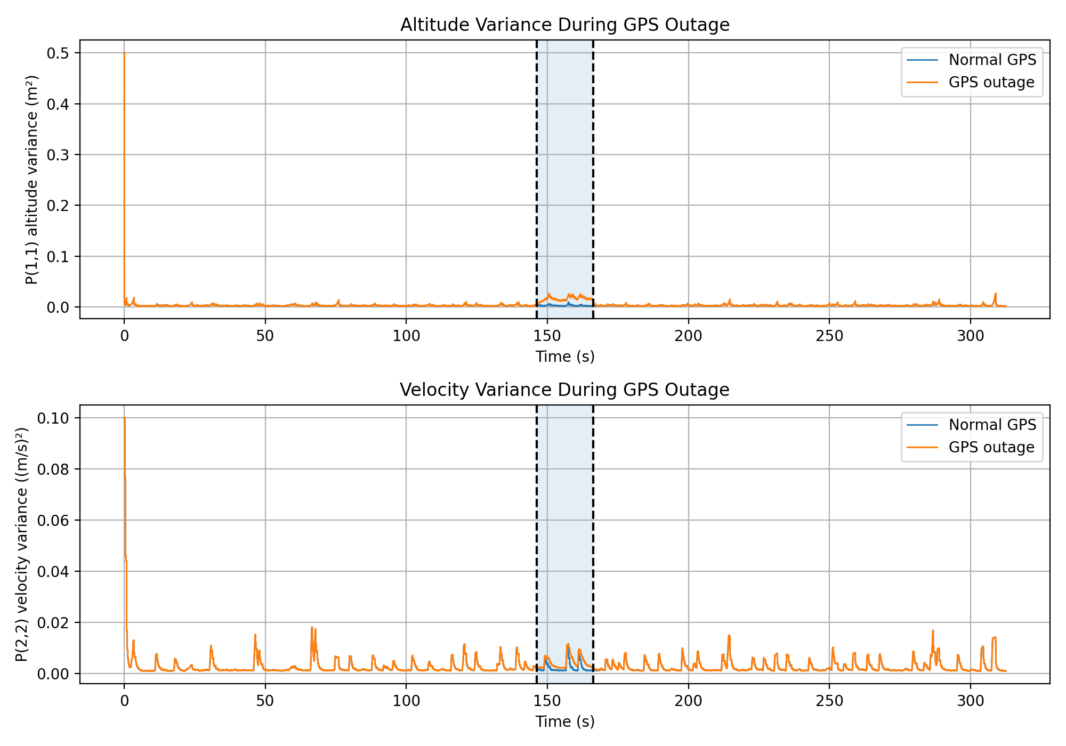
Figure 4: Covariance P diagonal entries during a 20 second GPS outage. The shaded region marks the removed GPS measurements.
The artificial GPS outage was applied from 146.2 s to 166.2 s. The plot shows P(1,1), the altitude variance, and P(2,2), the vertical velocity variance. During the prediction step, uncertainty increases according to:
P = F*P*F' + Q
During a measurement update, uncertainty is reduced because the measurement gives the filter new information:
P = (I - K*H)*P
During the GPS outage, the filter still receives barometer updates, so the covariance does not explode. However, the outage case generally has larger covariance than the normal GPS case because one source of altitude correction is missing. In this run, the maximum altitude variance inside the outage window is about 0.02637 m^2 and the maximum velocity variance inside the outage window is about 0.01164 (m/s)^2. When GPS measurements return, the covariance decreases again because the filter regains GPS measurement information.

6.4 Task H: How the code handled multi-rate sensors
The final code uses an event-based multi-rate update strategy. The IMU timestamps are the main prediction timeline because the IMU is the highest-rate signal. At each IMU step, the code checks whether a barometer or GPS measurement timestamp falls between the previous IMU time and the current IMU time. If it does, the corresponding update is applied.
This is appropriate because each real sensor measurement is used once, at its own timestamp. The method avoids nearest-neighbour lookup, which could accidentally use future measurements or reuse one measurement multiple times. It also avoids interpolating GPS and barometer data to a common rate, which would create artificial measurements that were never actually observed.
In Part 2, the barometer and GPS altitude are processed as separate scalar updates because they do not necessarily occur at the same moments. In Part 3, GPS altitude and GPS vertical velocity are handled in one combined vector update because they come from the same GPS message and share a timestamp. This is the correct design for the multi-rate sensor fusion problem in this exercise.

7. Notes on units and alignment
The scripts include safety checks for ArduPilot units. Some ArduPilot logs store GPS altitude in centimetres and GPS vertical velocity in centimetres per second, with positive VZ downward. The code checks the magnitude of the values and converts them only if needed. GPS.VZ is also sign-flipped so that the filter uses positive velocity upward.
GPS altitude is aligned to the initial barometer altitude before plotting and fusion. This is necessary because GPS altitude may be absolute altitude above mean sea level, while the filter uses a local altitude reference. The ArduPilot POS.RelHomeAlt reference is plotted as relative altitude shifted by the initial barometer altitude.

8. Final submission checklist
- kalman_filter_full_report.docx
- kalmanFilter_part1.m
- part1_baro_only_altitude.png
- kalmanFilter_part2.m
- part2_baro_gps_altitude.png
- kalmanFilter_part3.m
- part3_gps_altitude_velocity.png
- kalmanFilter_part4_outage.m
- part4_P_evolution_gps_outage.png
Before submitting: open the MATLAB scripts once, make sure they run in the same folder as solar.mat, and verify that the generated PNG file names match the checklist above.

